**Bundles of All Shapes and Sizes**

Creating a quote means choosing products, and some products must be sold with other products. This fact brings us to a central concept in Salesforce CPQ: the bundle. A bundle is simply a group of products we know should be sold together. When the sales rep chooses to sell the bundle, all the related products come along for the ride. There are three types of bundles. We use a food analogy to describe each type.

* **Static bundle**: These bundles always have the same products together, in the same quantities, with no changes allowed. Imagine a BLT sandwich. We always need bacon, lettuce, tomato, and two slices of toast. Otherwise, it’s not a BLT anymore!
* **Configurable bundle**: This bundle can be customized to your liking, with some limits to prevent impossible configurations. It’s like a build-your-own burrito. You choose the type of beans you want, the heat of the salsa, and if you want sour cream or not. Each customer gets a burrito with just the right fillings, which are probably different from the fillings chosen by the next customer.
* **Nested bundle**: This is a bundle inside another bundle. You might have a configurable hamburger bundle nested inside a combo meal bundle. In Salesforce CPQ, you can nest bundles as much as you want, but we recommend only going one or two levels deep.

## Control How Reps Configure Bundles

Giving sales reps the ability to configure bundles is a great way to make sure they sell the right products together, while also allowing some variation in how they sell. Some bundles are configured almost every time they are sold, while others are only configured occasionally, or maybe never. Salesforce CPQ gives admins the option to choose when and how bundles are configured throughout the sales process. You can also choose how bundles appear and behave in the Quote Line Editor, and what happens when you select more than one bundle to configure at a time.

## Configuration Type and Configuration Event

You can decide when the sales rep gets to configure a bundle. With the laptop bundle you configured in the last unit, you were prompted to make your choices immediately after selecting the laptop. Two fields on the laptop product record control when and how the user can configure the bundle: Configuration Type and Configuration Event.

Here’s how these two fields affect how sales reps interact with bundles.

| **Configuration Type** | **Configuration Event** | **Experience** | **Scenario** |
| --- | --- | --- | --- |
| Allowed | Always | Show configuration page immediately after selection, allow reps to reconfigure [1] | Bundles that often need to be customized for each customer |
| Allowed | Edit | Don’t show configuration page after selection, but allow reps to reconfigure [2] | Bundles that only occasionally need customization |
| Disabled | n/a | Never show configuration page [3] | Bundles that are never customized |
| Allowed | Add | Show configuration page only once [4] | Bundles that inform later decisions in the sales process, such as what configurations are allowed for the next bundle that’s added; this setting is rarely used |

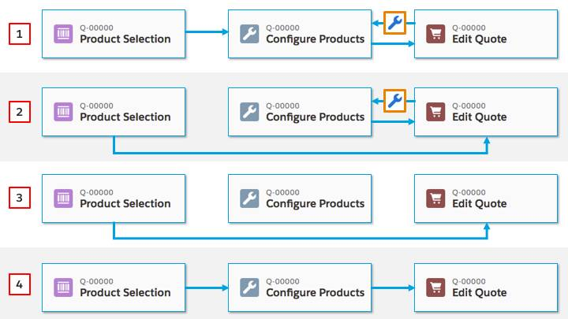

If you have a nested bundle that sales reps have to configure, set the Configuration Type to Required. A red line appears next to the required bundle, much like the red line you see next to a required field. When the sales rep configures the nested bundle, the red line goes away, and they can save the outer bundle to the Quote Line Editor. If they never configure the nested bundle, they receive an error message when they try to save the outer bundle.

## Multiple Bundles

Sometimes a sales rep chooses two bundles from the product selection page, and both bundles need to be configured. When this happens, the configuration page shows an expandable bar on the left. When expanded, the panel displays a list of configurable bundles. By default, clicking a bundle from the sidebar shows just that one bundle.

However, you can see all bundles at once by changing the Multiple Bundles View package level setting to Classic. With this mode, the sidebar acts more like a bookmark bar, scrolling the page to the selected bundle. Find package level settings in Setup by entering Installed Packages in the Quick Find box, then click **Installed Packages**. Next to Salesforce CPQ, click **Configure**.

## Visualize Product Hierarchy

To make bundles easier to distinguish in the Quote Line Editor, set the Visualize Product Hierarchy package level setting to True. This setting indents product names in quote lines that represent options, so that you can easily see that they’re related to the lead product. If you signed up for the special Developer Edition org with Salesforce CPQ, you can see this setting in action.

If you don’t want product names to be indented, just uncheck that setting. The quote lines for the options still have an icon next to them, and hovering over the icon tells you which quote line is the lead product.

## Keep Bundles Together

Typically, when a rep uses groups to organize their quote lines, they want all products within a bundle to appear in a single group. Furthermore, they want the entire bundle to stay together when moved into a different group. The Keep Bundles Together package level setting is enabled by default, but if you want to let reps split bundles across multiple groups you can disable that setting. Just remind sales reps to be careful not to split bundles when it doesn’t make sense.

Salesforce CPQ lets you, the Salesforce admin, control the experience of adding bundles to a quote so that sales reps have the easiest time possible putting their quotes together. In the next unit, we look at how admins create such cool bundles in the first place.

## Product Options Basics

A bundle is really just a bunch of products that we know should be sold together. For example, you might want to sell a printer, toner, paper, and two paper trays together. Those are all just products, much like the ones you’d see in any org. The magic happens when CPQ knows they’re supposed to be sold as a set.

You start building a bundle by choosing a lead product, one that’s always part of the bundle no matter what. It’s usually the most important piece of the bundle. In our printer bundle example, the printer itself is the best choice for the lead product. All of the other bundle products are like followers, tagging along whenever the printer is put on a quote.

After you decide on a lead product, how do you specify which products should tag along? Use a Product Option record. Think of the Product Option as the leash between a dog and the dog-walker. Without the leash, the dog doesn’t stay part of the pack for very long. With the leash, the dog goes where the dog-walker goes.

**Order and Selectability**

A Product Option (for simplicity, we’ll just call this an option from now on) does more than just connect a follower product to the lead product. It also describes how the follower behaves in the bundle. Here are a few option record fields that control option behavior.

* **Number**: Sorts the options on the Configure Products page. The lower the number, the higher in the list the option appears.  
  Tip: Number your options in increments of 10. That way, if you need to slip a new option between the first (10) and second (20), you can number it 15 without having to renumber everything.
* **Selected**: Selects the option by default. Choose Selected for an option when you want to give your sales reps guidance about what’s typical for a configuration.
* **Required**: Selects the option and prevents sales reps from deselecting it. The selection box is grayed out.

## Quantity Controls

You can use Options to control what changes your sales reps can make to the quantity of products within bundles. The table below shows how to use Quantity, Quantity Editable, and Min Quantity fields on the option to achieve different goals.

| **Goal** | **Quantity Field** | **Quantity Editable Field** | **Min Quantity Field** |
| --- | --- | --- | --- |
| Always require a quantity of 3; no changes allowed | 3 | False | <blank> |
| Suggest a starting quantity of 1, and let sales reps change it | <blank> | A blank quantity field causes CPQ to leave quantity editable, so the Quantity Editable field is ignored | <blank> |
| Suggest a starting quantity of 5, and let sales reps change it | 5 | True | <blank> |
| Suggest a starting quantity of 8, let the sales rep change it, but require at least 6 | 8 | True | 6 |
| Suggest a starting value of 10, and let the sales rep change it to anything 10 or greater | <blank> | A blank quantity field causes CPQ to leave quantity editable, so the Quantity Editable field is ignored | 10 |

The Max Quantity field is similar to Min Quantity, putting an upper limit to the quantity value allowed for the option.

## Summary

As we’ve seen, creating a bundle is really a matter of making connections between related products and configuring the behavior you want your reps to experience. This is just the beginning of a bigger story. In the next unit, we take a look at some other things we can do with options to make bundling even better.